Lab 3 - Images

Instructions
- Answer the below question in the boxes if needed.
- For coding exercises, code on your computer and zip all your code before submission.
- Please submit the assignment after you finish.

Part 1: Displaying images:
Steps:

- Go to VS Code and open the folder that we created in Lab 1
- Open the HTML file inside the folder.
- Extract the zip file in the project materials (lab3.zip) and you will have the following images (bird.png, human.jpg and space.png). Place them in the same directory (M1-HTML-CSS) as your HTML file.

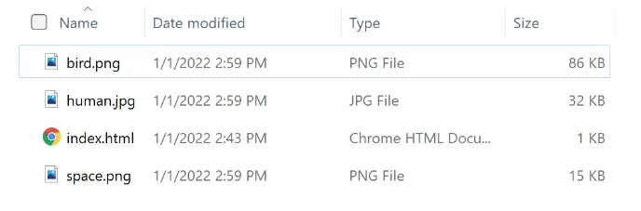Example Screenshot of putting the three images in same directory

- Display these 3 images on your HTML so they look like this (order does not matter)

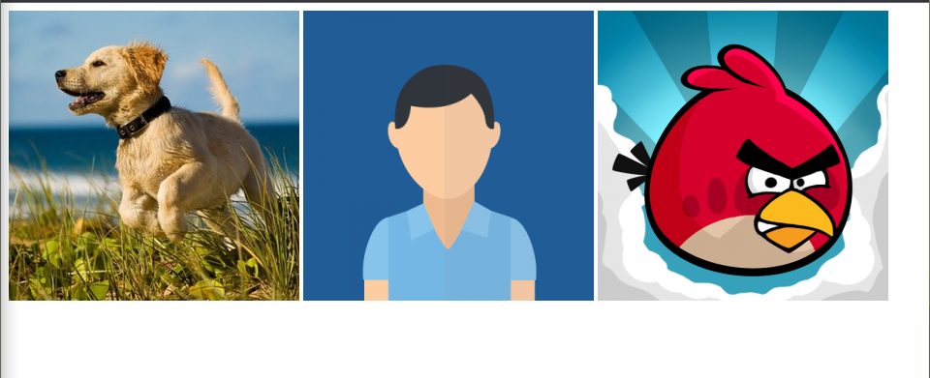
- Take a screenshot and name the screenshot as “part1”.

Part 2: Image Paths

- Create a new folder named “Inner Directory” in the same directory as the HTML Files and Images. Move the angry bird image (bird.png) inside the new folder.

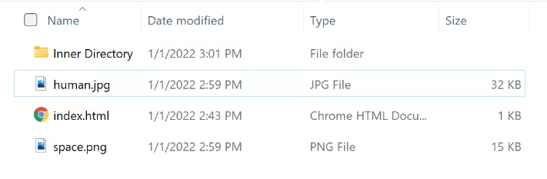
- If you have successfully moved the bird.jpg into the “Inner Directory” folder, your website should be broken now. The bird image is not showing up anymore. Fix this issue so all 3 images are showing up properly again by updating the HTML file.

Part 3: Image Links and Dimensions
- On top of your HTML code in part 2, please make the following changes
  - Make the angry bird image a link element i.e when we click on the angry bird image, we will be directed to https://www.angrybirds.com/
  - All the images have the same height and width now. Try to play around with the dimensions of the images (height and width) and make “bird.png” the largest image among the three on the page.
- Zip the entire folder (M1-HTML-CSS) with the “Part1'' screenshot and submit.

